Pentose Phosphate Pathway (Warburg-Dicken’s Pathway):
It involves the oxidation of Glucose-6-Phosphate to 6-Phosphogluconic acid which in turn is converted into pentose phosphates. In this pathway glucose-6-phosphate is directly oxidised without entering glycolysis, hence it is also known as Direct Oxidation Pathway or Hexose Monophosphate Shunt.

Reactions of Pentose Phosphate Pathway:
Starting from 6-molecules of glucose-6-phosphate, the various reactions of this pathway can be summarised as follows:
(1) 6 molecules of glucose-6-phosphate in the presence of coenzyme NADP are converted (oxidised) into 6 molecules of 6-phosphogluconolactone by the enzyme glucose-6-phosphate dehydrogenase. 6 molecules of NADP are reduced in the reaction which is reversible.
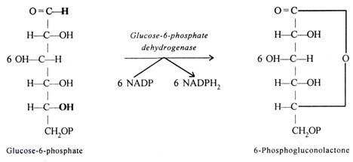
(2) 6-Phosphogluconolactone is hydrolysed by the enzyme Lactonase to produced 6 molecule of 6-phosphogluconic acid.
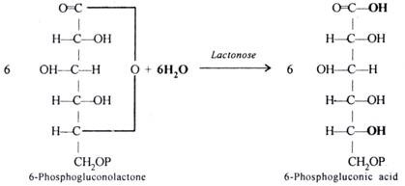
(3) 6-Phosphogluconic acid is oxidatively decarboxylated by the enzyme 6-Phosphogluconic acid dehydrogenase. 6 molecules of NADP are reduced, 6 molecules of CO₂ are released and 6 mols, of Ribulose-5-Phosphate are produced.
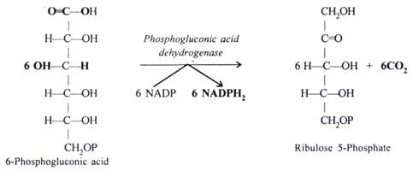
(4) 6 mols. of Ribulose-5-P isomerise into 4 mols. of XyIuIose-5-Phosphate and 2 mols. of Ribose-5-Phosphate in the presence of Ribulose phosphate-3-epimerase and Pentose phosphate isomerase respectively.
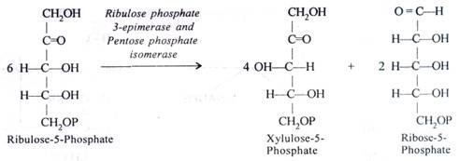
(5) 2 mols. of xylulose-5-Phosphate and 2 mols. of Ribose-5-phosphate combine in the presence of Transketolase to form 2 mols. of Sedoheptulose-7-Phosphate and 2 mols. of 3- Phosphoglyceraldehyde.
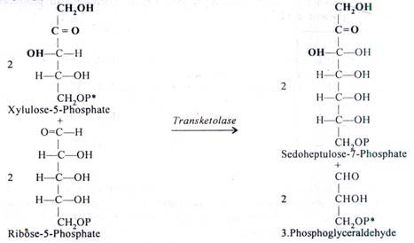
(6) 2 mols. of Sedoheptulose-7-Phosphate and 2 mols. of 3-Phosphoglyceraldehyde combine in the presence of Transaldolase to form 2 mols. of Fructose-6-Phosphate and 2 mols. of Erythrose-4-Phosphate (4-carbon atoms sugar).
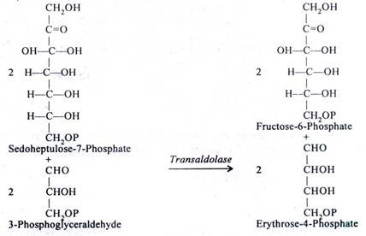
(7) 2 mols. of Erythose-4-Phosphate react with remaining two mols. of xylulose-5-Phosphate (see reaction No. 4 and 5) in the presence of Transketolase to form 2 mols. of Fructose- 6-Phosphate and 2 mols of 3-Phosphoglyceraldehyde.
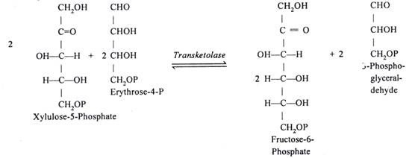
(8) One mol. of 3-phosphoglyceraldehyde isomerises into dihydroxyacetone phosphate. The enzyme is Phosphotriose isomerase.
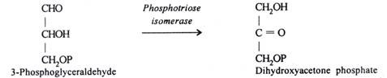
(9) Remaining one mole, of 3-Phosphoglyceraldehyde unites with Dihydroxyacetone phosphate in presence of Aldolase to form one mol. of Fructose 1, 6-bisphosphate. The latter, in the presence of Phosphatase forms one mol. of Fructose 6-Phosphate.
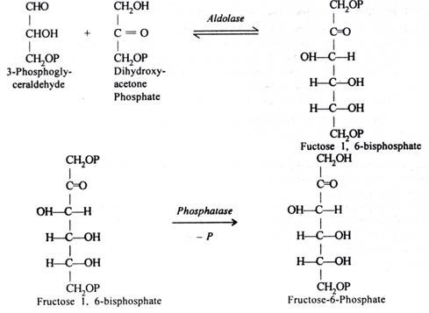
(10) 5 molecules of Fructose-6-phosphate produced in reactions 6, 7 and 9, isomerise into 5 mols. of Glucose-6-P in presence of Phosphohexose isomerase.
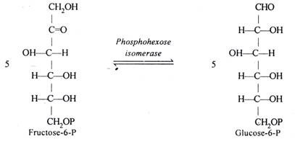
To summarise, 6 mols. of Glucose-6-P which enter into this pathway after oxidation produce 6 mols. of CO₂ (Reaction No. 3. CO₂ comes from C-No. 1 of the glucose molecule) and 12 mols. of reduced coenzymes NADPH₂ (reaction 1 and 3) while 5 mols of Glucose-6-Phosphate are regenerated (Reaction No. 10).
6 (Glucose-6-P) + 12 NADP⁺ → 5 (Glucose-6-P) + 12 (NADPH + H⁺) + 6 CO₂
In other words one mol. of Glucose-6-P after oxidation produces 6-mols. of CO₂ and 12 (NADPH + H⁺) molecules.
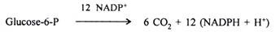
All the enzymes of pentose phosphate pathway are present in cytosol.

Significance of Pentose-Phosphate-Pathway:
(i) It provides alternative route for carbohydrate breakdown.
(ii) It generates NADPH molecules which are used as reductants in biosynthetic processes under conditions when NADPH molecules are not generated by photosynthesis. It is therefore, especially important in non-photosynthetic tissues such as in differentiating tissues, germinating seeds and during periods of darkness. Production of NADPH is not linked to ATP generation in pentose phosphate pathway.
(iii) It provides Ribose sugars for the synthesis of nucleic acids
(iv) It plays important role in fixation of CO₂ in photosynthesis through Ribulose-5-Phosphate. (Ribulose 1, 5-bisphosphate derived from Ribulose-5-Phosphate is the primary acceptor of CO₂ in photosynthesis).
(v) It provides Erythrose-4-phosphate which is required for the synthesis of shikimic acid. The latter is precursor of aromatic ring compounds.
(In addition to the above pathway for the oxidation of carbohydrates, still other routes have been identified in some micro-organisms and enzyme systems discovered. In all such cases the initial steps of glucose oxidation differ from glycolysis but ultimately pyruvic acid is produced.
